Keeve Lab 7

## Question 2

Accessing arctic pollen data

library(palaeoSig)

## Loading required package: vegan

## Loading required package: permute

## Loading required package: lattice

## This is vegan 2.5-2

data(arctic.pollen)

Squart root transform arctic pollen data

arctic_pollen_sqrt <- sqrt(arctic.pollen)

Running CA on arctic pollen data

library(vegan)  
arctic_pollen_sqrt_cca <- cca(arctic_pollen_sqrt)

Making screeplot…

screeplot(arctic_pollen_sqrt_cca,bstick=TRUE)

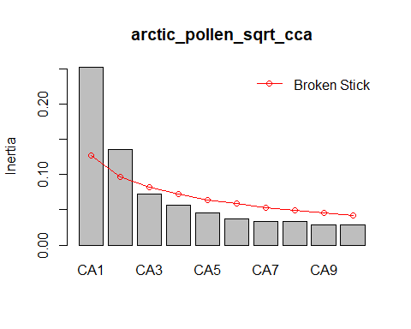

Explained variances are CA1 and CA2

Generating joint plot

plot(arctic_pollen_sqrt_cca,scaling=2)  
points(arctic_pollen_sqrt_cca,display="sites",scaling=2,col="cadetblue")  
points(arctic_pollen_sqrt_cca,display="species",scaling=2,pch = 16,col="blanchedalmond")

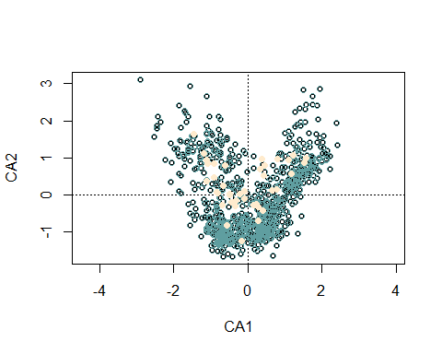

There’s an arch effect!

Ordination surface…

data(arctic.env)  
plot(arctic_pollen_sqrt_cca,scaling=2)  
points(arctic_pollen_sqrt_cca,display="sites",scaling=2,col="cadetblue")  
points(arctic_pollen_sqrt_cca,display="species",scaling=2,pch = 16,col="blanchedalmond")



ordisurf(x=arctic_pollen_sqrt_cca,arctic.env$tjul)

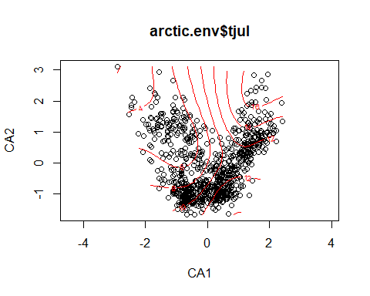

##   
## Family: gaussian   
## Link function: identity   
##   
## Formula:  
## y ~ s(x1, x2, k = 10, bs = "tp", fx = FALSE)  
##   
## Estimated degrees of freedom:  
## 8.84 total = 9.84   
##   
## REML score: 1699.243

plot(arctic_pollen_sqrt_cca,choices=c(2,3),scaling=2)

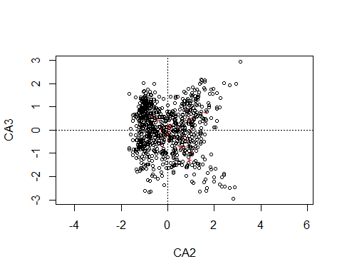

ordisurf(x=arctic_pollen_sqrt_cca,arctic.env$tjul,choices=c(2,3))

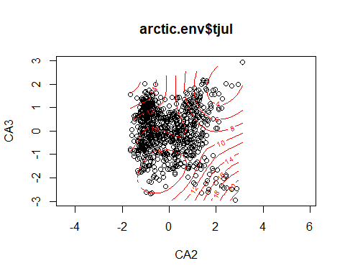

##   
## Family: gaussian   
## Link function: identity   
##   
## Formula:  
## y ~ s(x1, x2, k = 10, bs = "tp", fx = FALSE)  
##   
## Estimated degrees of freedom:  
## 8.76 total = 9.76   
##   
## REML score: 2000.047

## Question 4

RDA_Data <- readRDS("~/CKGit/RDA_Data.RDS")  
RDA_Data_sqrt <- sqrt(RDA_Data)

Constrain by July temperature

RDA_DATA_jul <- vegan::rda(RDA_Data_sqrt,y=RDA_Data$temp.rec)

Constrain by annual precipitation

RDA_Data_annp <- vegan::rda(RDA_Data_sqrt,y=RDA_Data$precip.rec)

Constrain by both

RDA_Data_tjul_annp <- vegan::rda(RDA_Data_sqrt,RDA_Data$precip.rec,RDA_Data$temp.rec)

Looking at variances

summary(RDA_Data_annp)

##   
## Call:  
## rda(X = RDA_Data_sqrt, y = RDA_Data$precip.rec)   
##   
## Partitioning of variance:  
## Inertia Proportion  
## Total 11.03 1  
## Unconstrained 11.03 1  
##   
## Eigenvalues, and their contribution to the variance   
##   
## Importance of components:  
## PC1 PC2 PC3 PC4 PC5 PC6 PC7  
## Eigenvalue 6.507 2.3969 0.46694 0.34664 0.24900 0.15050 0.11654  
## Proportion Explained 0.590 0.2173 0.04234 0.03143 0.02258 0.01365 0.01057  
## Cumulative Proportion 0.590 0.8073 0.84966 0.88109 0.90366 0.91731 0.92787  
## PC8 PC9 PC10 PC11 PC12  
## Eigenvalue 0.108278 0.105202 0.089747 0.076452 0.062732  
## Proportion Explained 0.009817 0.009538 0.008137 0.006932 0.005688  
## Cumulative Proportion 0.937690 0.947229 0.955366 0.962298 0.967985  
## PC13 PC14 PC15 PC16 PC17 PC18  
## Eigenvalue 0.054630 0.05239 0.043585 0.039730 0.037796 0.031717  
## Proportion Explained 0.004953 0.00475 0.003952 0.003602 0.003427 0.002876  
## Cumulative Proportion 0.972939 0.97769 0.981640 0.985243 0.988669 0.991545  
## PC19 PC20 PC21 PC22 PC23  
## Eigenvalue 0.022225 0.020933 0.019152 0.012589 0.0077398  
## Proportion Explained 0.002015 0.001898 0.001736 0.001141 0.0007018  
## Cumulative Proportion 0.993560 0.995458 0.997195 0.998336 0.9990378  
## PC24 PC25 PC26 PC27  
## Eigenvalue 0.0057748 0.0042984 5.222e-04 1.667e-05  
## Proportion Explained 0.0005236 0.0003897 4.735e-05 1.512e-06  
## Cumulative Proportion 0.9995614 0.9999511 1.000e+00 1.000e+00  
##   
## Scaling 2 for species and site scores  
## * Species are scaled proportional to eigenvalues  
## * Sites are unscaled: weighted dispersion equal on all dimensions  
## * General scaling constant of scores: 4.693534   
##   
##   
## Species scores  
##   
## PC1 PC2 PC3 PC4 PC5 PC6  
## Alnus 0.9381838 -0.02980 -0.773714 0.099368 -0.152062 0.010681  
## Betula 0.5901001 0.01096 0.040577 -0.597845 -0.143418 0.082440  
## Corylus 0.3058762 -0.32802 -0.130219 0.155654 -0.056950 0.140782  
## Juniperu -0.3976017 0.87422 0.144325 0.329021 -0.359740 -0.145092  
## Picea -0.7540741 0.96087 -0.254849 -0.106832 0.307512 -0.157114  
## Pinus.sy -0.5156308 -1.12458 0.144143 0.128591 0.014218 -0.150720  
## Quercus 0.1192480 0.02695 0.107232 -0.134449 -0.081066 -0.191191  
## Salix.un -0.1576250 0.09394 -0.032127 0.018053 0.099726 0.081266  
## Ulmus 0.3852251 -0.19255 -0.136343 0.055108 0.078023 -0.054157  
## Artemisi -0.1104216 0.12311 -0.028073 0.050118 -0.108188 -0.053311  
## Carex.ty -0.1839002 0.37321 0.112781 0.120568 0.009932 0.084208  
## Com.Lig. 0.0437995 0.24599 0.070403 -0.089564 -0.049565 -0.050910  
## Cyperace -0.0006295 0.22766 -0.043090 0.106913 0.069759 0.111798  
## Filipend 0.0678001 0.23427 0.121340 -0.054705 -0.009208 -0.020919  
## Graminea -0.5064031 0.82723 0.015427 0.039420 0.011018 0.214171  
## Rumx.act -0.0573947 0.27576 0.048397 -0.162275 -0.121919 0.020093  
## Rumx.a.a -0.0705753 0.33937 0.084511 -0.098027 -0.093053 -0.077640  
## Solidago -0.1100104 0.22234 0.038927 -0.019062 -0.053176 0.066932  
## Urtica -0.1543048 0.33482 -0.214296 -0.121681 0.138623 -0.186743  
## Dryo.f.m 0.4014388 -0.03527 -0.002720 -0.088829 0.032771 -0.016417  
## Dryo.typ 0.4221246 0.25566 0.134667 0.059021 0.196996 0.110792  
## Gymnocar 0.0736818 0.01030 0.145799 0.116066 0.281931 0.003092  
## Lyco.ann 0.0980888 -0.04820 0.027307 -0.105461 -0.038964 0.069465  
## Pteridiu 0.0936462 0.22229 0.025527 0.028411 -0.019852 -0.095781  
## Selagine -0.1037510 0.21480 -0.008471 0.033832 -0.112649 0.092044  
## precip.rec 3.1253677 0.38495 0.204201 0.114500 0.068250 -0.074036  
## temp.rec 0.0109969 -0.09255 -0.054335 -0.003262 0.009461 -0.041289  
##   
##   
## Site scores (weighted sums of species scores)  
##   
## PC1 PC2 PC3 PC4 PC5 PC6  
## 1 -0.82893 0.571227 -0.92135 -1.27090 2.359605 -1.51670  
## 2 -0.43610 1.105008 -0.12624 0.36901 1.224209 0.81873  
## 3 -0.09754 1.374440 0.14582 0.76957 0.260278 1.45899  
## 4 -0.32475 1.178466 0.02874 0.97844 -0.512950 -0.44903  
## 5 -0.07796 1.382397 0.40378 1.41407 -0.365554 0.20208  
## 6 -0.70941 0.977266 -0.48138 0.33889 -0.264468 0.74575  
## 7 -0.81362 0.423985 -0.67327 0.59795 0.316491 -0.21649  
## 8 -0.98986 0.334792 -0.33314 -0.89735 0.044018 0.58132  
## 9 -0.82303 0.119512 -0.94175 -0.75708 0.154269 -0.60819  
## 10 -0.58260 0.716724 -0.10663 0.62180 -0.851150 -0.73532  
## 11 -0.44417 0.979138 0.51520 0.43862 0.087166 -0.17484  
## 12 -0.21137 0.851526 0.53872 0.87190 0.134366 -0.44869  
## 13 -0.27097 0.729224 0.55014 -0.47859 -0.066924 -0.65663  
## 14 -0.81839 0.216665 -0.37994 -1.16907 0.123130 0.64181  
## 15 -0.06966 0.231424 -0.27840 -1.06993 -0.136587 -0.47488  
## 16 -0.55412 0.159659 -0.26862 -1.37406 -1.240461 -0.21223  
## 17 -0.53441 -0.112046 -0.63107 -0.28617 -1.103676 -1.10439  
## 18 -0.29039 -0.174184 0.07253 -0.33976 -0.597943 0.81298  
## 19 0.05828 -0.004354 0.80590 -0.66175 -0.558991 0.42304  
## 20 0.31794 -0.087987 1.24842 0.11631 -0.267013 -0.05850  
## 21 0.21741 0.045861 1.15304 -0.37089 -1.143571 0.06355  
## 22 0.32263 -0.216511 -0.04096 -1.03690 -0.986239 -0.57511  
## 23 0.64236 0.065463 0.30520 0.04567 -0.649729 -0.10168  
## 24 1.11562 0.141997 0.78965 0.04603 0.087739 -0.92212  
## 25 0.94855 -0.020246 0.88914 0.01776 -0.004444 -1.43062  
## 26 0.54146 -0.281678 0.51286 -0.51437 0.578833 0.83675  
## 27 1.11211 0.311328 1.09012 -0.75663 0.476285 -0.04812  
## 28 0.36528 -0.223786 0.45403 -0.47611 0.326068 0.48315  
## 29 1.11421 0.096541 0.15360 0.18732 -0.052155 0.30644  
## 30 1.11516 -0.013367 0.08216 -0.53007 0.834416 0.65123  
## 31 1.20911 0.208269 -0.58622 -0.66459 0.744771 0.14218  
## 32 1.39357 -0.153413 -1.17103 0.32011 0.786324 0.82527  
## 33 1.30946 -0.166802 -0.71790 0.62223 -0.125591 -0.72361  
## 34 0.26169 -0.592224 -1.12701 0.62424 -0.373651 -0.02779  
## 35 0.67362 -0.671635 -0.94482 0.85000 0.631152 -0.80649  
## 36 0.30392 -0.516642 -0.57755 -0.50969 -0.519846 0.21078  
## 37 0.31668 -0.449312 -1.09512 0.14035 -0.790778 1.26182  
## 38 0.05816 -0.697315 -1.04004 0.45610 -0.057581 0.38087  
## 39 -0.30103 -0.828137 -0.67294 0.80000 -0.517120 0.48880  
## 40 -0.24254 -0.970165 -0.24530 0.88539 -0.054276 -0.42949  
## 41 -0.59589 -1.189897 0.39582 0.92761 0.054893 -0.94777  
## 42 -0.75177 -1.356891 0.15598 0.19590 -0.167348 -0.33901  
## 43 -0.79476 -1.087366 0.86874 -0.50790 -0.193295 1.15046  
## 44 -0.81482 -1.231157 0.85971 0.43062 0.916385 0.55862  
## 45 -1.01910 -1.175792 1.34139 0.60594 1.460944 -0.03695

summary(RDA_DATA_jul)

##   
## Call:  
## rda(X = RDA_Data_sqrt, y = RDA_Data$temp.rec)   
##   
## Partitioning of variance:  
## Inertia Proportion  
## Total 11.03 1  
## Unconstrained 11.03 1  
##   
## Eigenvalues, and their contribution to the variance   
##   
## Importance of components:  
## PC1 PC2 PC3 PC4 PC5 PC6 PC7  
## Eigenvalue 6.507 2.3969 0.46694 0.34664 0.24900 0.15050 0.11654  
## Proportion Explained 0.590 0.2173 0.04234 0.03143 0.02258 0.01365 0.01057  
## Cumulative Proportion 0.590 0.8073 0.84966 0.88109 0.90366 0.91731 0.92787  
## PC8 PC9 PC10 PC11 PC12  
## Eigenvalue 0.108278 0.105202 0.089747 0.076452 0.062732  
## Proportion Explained 0.009817 0.009538 0.008137 0.006932 0.005688  
## Cumulative Proportion 0.937690 0.947229 0.955366 0.962298 0.967985  
## PC13 PC14 PC15 PC16 PC17 PC18  
## Eigenvalue 0.054630 0.05239 0.043585 0.039730 0.037796 0.031717  
## Proportion Explained 0.004953 0.00475 0.003952 0.003602 0.003427 0.002876  
## Cumulative Proportion 0.972939 0.97769 0.981640 0.985243 0.988669 0.991545  
## PC19 PC20 PC21 PC22 PC23  
## Eigenvalue 0.022225 0.020933 0.019152 0.012589 0.0077398  
## Proportion Explained 0.002015 0.001898 0.001736 0.001141 0.0007018  
## Cumulative Proportion 0.993560 0.995458 0.997195 0.998336 0.9990378  
## PC24 PC25 PC26 PC27  
## Eigenvalue 0.0057748 0.0042984 5.222e-04 1.667e-05  
## Proportion Explained 0.0005236 0.0003897 4.735e-05 1.512e-06  
## Cumulative Proportion 0.9995614 0.9999511 1.000e+00 1.000e+00  
##   
## Scaling 2 for species and site scores  
## * Species are scaled proportional to eigenvalues  
## * Sites are unscaled: weighted dispersion equal on all dimensions  
## * General scaling constant of scores: 4.693534   
##   
##   
## Species scores  
##   
## PC1 PC2 PC3 PC4 PC5 PC6  
## Alnus 0.9381838 -0.02980 -0.773714 0.099368 -0.152062 0.010681  
## Betula 0.5901001 0.01096 0.040577 -0.597845 -0.143418 0.082440  
## Corylus 0.3058762 -0.32802 -0.130219 0.155654 -0.056950 0.140782  
## Juniperu -0.3976017 0.87422 0.144325 0.329021 -0.359740 -0.145092  
## Picea -0.7540741 0.96087 -0.254849 -0.106832 0.307512 -0.157114  
## Pinus.sy -0.5156308 -1.12458 0.144143 0.128591 0.014218 -0.150720  
## Quercus 0.1192480 0.02695 0.107232 -0.134449 -0.081066 -0.191191  
## Salix.un -0.1576250 0.09394 -0.032127 0.018053 0.099726 0.081266  
## Ulmus 0.3852251 -0.19255 -0.136343 0.055108 0.078023 -0.054157  
## Artemisi -0.1104216 0.12311 -0.028073 0.050118 -0.108188 -0.053311  
## Carex.ty -0.1839002 0.37321 0.112781 0.120568 0.009932 0.084208  
## Com.Lig. 0.0437995 0.24599 0.070403 -0.089564 -0.049565 -0.050910  
## Cyperace -0.0006295 0.22766 -0.043090 0.106913 0.069759 0.111798  
## Filipend 0.0678001 0.23427 0.121340 -0.054705 -0.009208 -0.020919  
## Graminea -0.5064031 0.82723 0.015427 0.039420 0.011018 0.214171  
## Rumx.act -0.0573947 0.27576 0.048397 -0.162275 -0.121919 0.020093  
## Rumx.a.a -0.0705753 0.33937 0.084511 -0.098027 -0.093053 -0.077640  
## Solidago -0.1100104 0.22234 0.038927 -0.019062 -0.053176 0.066932  
## Urtica -0.1543048 0.33482 -0.214296 -0.121681 0.138623 -0.186743  
## Dryo.f.m 0.4014388 -0.03527 -0.002720 -0.088829 0.032771 -0.016417  
## Dryo.typ 0.4221246 0.25566 0.134667 0.059021 0.196996 0.110792  
## Gymnocar 0.0736818 0.01030 0.145799 0.116066 0.281931 0.003092  
## Lyco.ann 0.0980888 -0.04820 0.027307 -0.105461 -0.038964 0.069465  
## Pteridiu 0.0936462 0.22229 0.025527 0.028411 -0.019852 -0.095781  
## Selagine -0.1037510 0.21480 -0.008471 0.033832 -0.112649 0.092044  
## precip.rec 3.1253677 0.38495 0.204201 0.114500 0.068250 -0.074036  
## temp.rec 0.0109969 -0.09255 -0.054335 -0.003262 0.009461 -0.041289  
##   
##   
## Site scores (weighted sums of species scores)  
##   
## PC1 PC2 PC3 PC4 PC5 PC6  
## 1 -0.82893 0.571227 -0.92135 -1.27090 2.359605 -1.51670  
## 2 -0.43610 1.105008 -0.12624 0.36901 1.224209 0.81873  
## 3 -0.09754 1.374440 0.14582 0.76957 0.260278 1.45899  
## 4 -0.32475 1.178466 0.02874 0.97844 -0.512950 -0.44903  
## 5 -0.07796 1.382397 0.40378 1.41407 -0.365554 0.20208  
## 6 -0.70941 0.977266 -0.48138 0.33889 -0.264468 0.74575  
## 7 -0.81362 0.423985 -0.67327 0.59795 0.316491 -0.21649  
## 8 -0.98986 0.334792 -0.33314 -0.89735 0.044018 0.58132  
## 9 -0.82303 0.119512 -0.94175 -0.75708 0.154269 -0.60819  
## 10 -0.58260 0.716724 -0.10663 0.62180 -0.851150 -0.73532  
## 11 -0.44417 0.979138 0.51520 0.43862 0.087166 -0.17484  
## 12 -0.21137 0.851526 0.53872 0.87190 0.134366 -0.44869  
## 13 -0.27097 0.729224 0.55014 -0.47859 -0.066924 -0.65663  
## 14 -0.81839 0.216665 -0.37994 -1.16907 0.123130 0.64181  
## 15 -0.06966 0.231424 -0.27840 -1.06993 -0.136587 -0.47488  
## 16 -0.55412 0.159659 -0.26862 -1.37406 -1.240461 -0.21223  
## 17 -0.53441 -0.112046 -0.63107 -0.28617 -1.103676 -1.10439  
## 18 -0.29039 -0.174184 0.07253 -0.33976 -0.597943 0.81298  
## 19 0.05828 -0.004354 0.80590 -0.66175 -0.558991 0.42304  
## 20 0.31794 -0.087987 1.24842 0.11631 -0.267013 -0.05850  
## 21 0.21741 0.045861 1.15304 -0.37089 -1.143571 0.06355  
## 22 0.32263 -0.216511 -0.04096 -1.03690 -0.986239 -0.57511  
## 23 0.64236 0.065463 0.30520 0.04567 -0.649729 -0.10168  
## 24 1.11562 0.141997 0.78965 0.04603 0.087739 -0.92212  
## 25 0.94855 -0.020246 0.88914 0.01776 -0.004444 -1.43062  
## 26 0.54146 -0.281678 0.51286 -0.51437 0.578833 0.83675  
## 27 1.11211 0.311328 1.09012 -0.75663 0.476285 -0.04812  
## 28 0.36528 -0.223786 0.45403 -0.47611 0.326068 0.48315  
## 29 1.11421 0.096541 0.15360 0.18732 -0.052155 0.30644  
## 30 1.11516 -0.013367 0.08216 -0.53007 0.834416 0.65123  
## 31 1.20911 0.208269 -0.58622 -0.66459 0.744771 0.14218  
## 32 1.39357 -0.153413 -1.17103 0.32011 0.786324 0.82527  
## 33 1.30946 -0.166802 -0.71790 0.62223 -0.125591 -0.72361  
## 34 0.26169 -0.592224 -1.12701 0.62424 -0.373651 -0.02779  
## 35 0.67362 -0.671635 -0.94482 0.85000 0.631152 -0.80649  
## 36 0.30392 -0.516642 -0.57755 -0.50969 -0.519846 0.21078  
## 37 0.31668 -0.449312 -1.09512 0.14035 -0.790778 1.26182  
## 38 0.05816 -0.697315 -1.04004 0.45610 -0.057581 0.38087  
## 39 -0.30103 -0.828137 -0.67294 0.80000 -0.517120 0.48880  
## 40 -0.24254 -0.970165 -0.24530 0.88539 -0.054276 -0.42949  
## 41 -0.59589 -1.189897 0.39582 0.92761 0.054893 -0.94777  
## 42 -0.75177 -1.356891 0.15598 0.19590 -0.167348 -0.33901  
## 43 -0.79476 -1.087366 0.86874 -0.50790 -0.193295 1.15046  
## 44 -0.81482 -1.231157 0.85971 0.43062 0.916385 0.55862  
## 45 -1.01910 -1.175792 1.34139 0.60594 1.460944 -0.03695

summary(RDA_Data_tjul_annp)

##   
## Call:  
## rda(X = RDA_Data_sqrt, Y = RDA_Data$precip.rec, Z = RDA_Data$temp.rec)   
##   
## Partitioning of variance:  
## Inertia Proportion  
## Total 11.029 1.0000  
## Conditioned 1.521 0.1379  
## Constrained 6.408 0.5810  
## Unconstrained 3.100 0.2811  
##   
## Eigenvalues, and their contribution to the variance   
## after removing the contribution of conditiniong variables  
##   
## Importance of components:  
## RDA1 PC1 PC2 PC3 PC4 PC5 PC6  
## Eigenvalue 6.408 1.2147 0.35662 0.33056 0.24116 0.1236 0.10940  
## Proportion Explained 0.674 0.1278 0.03751 0.03477 0.02536 0.0130 0.01151  
## Cumulative Proportion 0.674 0.8017 0.83922 0.87399 0.89936 0.9124 0.92386  
## PC7 PC8 PC9 PC10 PC11 PC12  
## Eigenvalue 0.10778 0.095015 0.080108 0.06446 0.058151 0.053832  
## Proportion Explained 0.01134 0.009993 0.008425 0.00678 0.006116 0.005662  
## Cumulative Proportion 0.93519 0.945187 0.953613 0.96039 0.966509 0.972171  
## PC13 PC14 PC15 PC16 PC17 PC18  
## Eigenvalue 0.046924 0.04355 0.039597 0.033914 0.023852 0.020970  
## Proportion Explained 0.004935 0.00458 0.004165 0.003567 0.002509 0.002206  
## Cumulative Proportion 0.977106 0.98169 0.985851 0.989418 0.991926 0.994132  
## PC19 PC20 PC21 PC22 PC23  
## Eigenvalue 0.020313 0.012849 0.0082605 0.0071635 0.0043097  
## Proportion Explained 0.002136 0.001351 0.0008688 0.0007534 0.0004533  
## Cumulative Proportion 0.996268 0.997620 0.9984886 0.9992420 0.9996953  
## PC24 PC25 PC26 PC27  
## Eigenvalue 0.0021552 6.177e-04 1.241e-04 2.797e-07  
## Proportion Explained 0.0002267 6.497e-05 1.305e-05 2.942e-08  
## Cumulative Proportion 0.9999220 1.000e+00 1.000e+00 1.000e+00  
##   
## Accumulated constrained eigenvalues  
## Importance of components:  
## RDA1  
## Eigenvalue 6.408  
## Proportion Explained 1.000  
## Cumulative Proportion 1.000  
##   
## Scaling 2 for species and site scores  
## * Species are scaled proportional to eigenvalues  
## * Sites are unscaled: weighted dispersion equal on all dimensions  
## * General scaling constant of scores: 4.693534   
##   
##   
## Species scores  
##   
## RDA1 PC1 PC2 PC3 PC4  
## Alnus 8.730e-01 0.3582627 -0.2000505 0.6420107 -0.0457576  
## Betula 5.596e-01 -0.0712810 -0.6185817 -0.1432882 0.0953581  
## Corylus 2.645e-01 -0.1428757 0.0750122 0.1995728 0.0090774  
## Juniperu -2.950e-01 0.5124734 0.3319639 0.0437481 0.4460538  
## Picea -6.424e-01 0.9036690 0.0237096 -0.2223674 -0.2336759  
## Pinus.sy -6.096e-01 -0.7500838 0.1933956 -0.0596298 0.0249796  
## Quercus 1.270e-01 0.0056266 -0.0757116 -0.1729816 0.1610472  
## Salix.un -1.470e-01 0.0677221 0.0232287 0.0083398 -0.1177429  
## Ulmus 3.581e-01 -0.0276368 0.0217519 0.0728595 -0.0741617  
## Artemisi -9.745e-02 0.1325147 0.0508357 0.0109119 0.1345498  
## Carex.ty -1.358e-01 0.1298563 0.1253299 0.0141919 -0.0181071  
## Com.Lig. 7.018e-02 0.0974899 -0.0728809 -0.0685677 0.0658314  
## Cyperace 2.252e-02 0.1207349 0.0718072 0.1006300 -0.1123326  
## Filipend 9.405e-02 0.0854256 -0.0227533 -0.1028970 0.0461566  
## Graminea -4.175e-01 0.5145297 0.0580036 -0.0153910 -0.0288691  
## Rumx.act -3.651e-02 0.1447456 -0.1568723 -0.0621105 0.1196911  
## Rumx.a.a -3.404e-02 0.2012154 -0.0569053 -0.1238954 0.1447241  
## Solidago -9.024e-02 0.0620127 -0.0440791 0.0450107 0.0101673  
## Urtica -1.256e-01 0.4370328 -0.0702569 -0.1108272 -0.0816312  
## Dryo.f.m 3.971e-01 -0.0213888 -0.0854233 -0.0464278 -0.0176727  
## Dryo.typ 4.571e-01 0.0213718 0.0673296 -0.0376357 -0.1940697  
## Gymnocar 8.791e-02 -0.0656218 0.1815281 -0.1268628 -0.2122500  
## Lyco.ann 8.926e-02 -0.0894032 -0.1220868 0.0057647 0.0023586  
## Pteridiu 1.176e-01 0.1419568 0.0395830 -0.0340349 0.0610386  
## Selagine -8.704e-02 0.0689985 -0.0218877 0.1254125 0.0456322  
## precip.rec 3.157e+00 0.0056498 0.0007096 0.0375876 0.0411859  
## temp.rec 9.464e-05 -0.0002682 -0.0005892 -0.0005044 0.0002601  
## PC5  
## Alnus 1.411e-01  
## Betula -7.456e-02  
## Corylus -2.380e-01  
## Juniperu 9.590e-03  
## Picea 1.161e-01  
## Pinus.sy 1.349e-01  
## Quercus 7.265e-02  
## Salix.un -1.490e-01  
## Ulmus -1.082e-02  
## Artemisi -9.357e-02  
## Carex.ty 2.436e-02  
## Com.Lig. 4.649e-02  
## Cyperace -4.918e-03  
## Filipend 1.047e-01  
## Graminea -2.412e-01  
## Rumx.act 4.528e-02  
## Rumx.a.a 1.292e-02  
## Solidago 7.969e-02  
## Urtica -4.586e-04  
## Dryo.f.m -4.134e-02  
## Dryo.typ 8.551e-02  
## Gymnocar -3.248e-02  
## Lyco.ann -5.279e-02  
## Pteridiu 3.494e-02  
## Selagine 4.348e-02  
## precip.rec -9.159e-03  
## temp.rec -8.559e-05  
##   
##   
## Site scores (weighted sums of species scores)  
##   
## RDA1 PC1 PC2 PC3 PC4 PC5  
## 1 -0.85213 1.75608 -0.46094 -1.782447 -1.688966 0.33070  
## 2 -0.31183 0.24465 0.18938 0.512585 -1.637720 0.65345  
## 3 0.05407 0.23450 0.38549 0.911891 -0.727937 -0.59814  
## 4 -0.22396 0.74563 0.89411 0.362751 0.660338 -0.25874  
## 5 0.02579 1.02833 1.52447 0.005586 0.741595 -0.77959  
## 6 -0.64609 0.96990 0.17237 0.489385 0.062215 -0.58951  
## 7 -0.79215 0.66746 0.54137 0.408280 -0.388143 0.30750  
## 8 -0.97621 0.49299 -0.79536 -0.260051 -0.242945 0.01769  
## 9 -0.84698 0.78330 -0.71604 -0.078818 -0.243894 1.30112  
## 10 -0.53926 0.76207 0.60090 0.175720 1.061233 0.46815  
## 11 -0.32807 0.06513 0.47813 -0.006168 -0.050946 0.23808  
## 12 -0.14017 0.53132 1.15786 -0.448319 0.325169 -0.27393  
## 13 -0.21780 0.54651 -0.03747 -1.074386 0.560298 -0.27894  
## 14 -0.81467 0.41459 -1.08375 -0.323289 -0.313961 -1.00355  
## 15 -0.05777 0.28400 -1.05392 -0.268980 0.094899 0.35981  
## 16 -0.52772 -0.13867 -1.68346 0.365838 0.764663 1.37868  
## 17 -0.60411 0.97286 -0.18109 -0.267226 1.499014 -0.75666  
## 18 -0.26814 -0.76445 -0.77290 0.798822 0.007848 0.87062  
## 19 0.07599 -0.48132 -0.61960 -0.385064 0.555792 0.33124  
## 20 0.35719 -0.96622 0.28860 -0.451019 0.438137 -0.23212  
## 21 0.27672 -1.05851 -0.44963 -0.078030 1.069876 0.14229  
## 22 0.27287 0.31021 -0.92276 -0.589753 1.300915 -0.98559  
## 23 0.65184 -0.11997 -0.04519 0.045596 0.757434 -0.45197  
## 24 1.15496 -0.44857 0.28454 -0.572211 0.221296 0.69086  
## 25 0.94316 -0.07288 0.50077 -1.140421 0.712319 1.00862  
## 26 0.54950 -0.80361 -0.55783 -0.127614 -0.789170 0.11875  
## 27 1.16443 -0.39703 -0.33351 -1.173260 -0.159087 0.32041  
## 28 0.35666 -0.40784 -0.40818 -0.390710 -0.254308 -0.83202  
## 29 1.13733 -0.24840 0.06031 0.253612 -0.075309 -0.03349  
## 30 1.11010 -0.01544 -0.40579 -0.425815 -0.832768 -0.23692  
## 31 1.22291 0.23998 -0.73460 0.047430 -0.966933 0.17421  
## 32 1.33887 0.68096 0.14176 0.560806 -1.025286 -0.99074  
## 33 1.26564 0.45531 0.50061 0.415984 0.234940 0.31158  
## 34 0.19758 -0.01574 0.06558 1.381871 -0.088219 0.78733  
## 35 0.57417 0.40473 0.75244 0.431145 -0.488203 0.77749  
## 36 0.23497 0.08741 -0.73152 0.318963 0.362201 -0.67533  
## 37 0.28707 -0.35021 -0.70662 1.846262 -0.120202 -0.50209  
## 38 -0.02777 0.11760 0.05194 0.982860 -0.226219 -0.66230  
## 39 -0.37005 -0.45030 0.29027 1.314199 0.048324 0.09710  
## 40 -0.33402 -0.36521 0.82706 0.372727 0.146052 0.06897  
## 41 -0.69899 -0.68092 1.13165 -0.200858 0.304423 1.69091  
## 42 -0.86626 -0.82260 0.28837 -0.078856 0.244208 0.37109  
## 43 -0.84602 -1.42617 -0.37169 -0.323013 -0.027020 -1.43852  
## 44 -0.87654 -1.45582 0.68019 -0.375639 -0.843156 -1.10972  
## 45 -1.08508 -1.30563 1.26365 -1.180366 -0.982797 -0.12682  
##   
##   
## Site constraints (linear combinations of constraining variables)  
##   
## RDA1 PC1 PC2 PC3 PC4 PC5  
## 1 -0.75014 1.75608 -0.46094 -1.782447 -1.688966 0.33070  
## 2 -0.33534 0.24465 0.18938 0.512585 -1.637720 0.65345  
## 3 0.00738 0.23450 0.38549 0.911891 -0.727937 -0.59814  
## 4 -0.17348 0.74563 0.89411 0.362751 0.660338 -0.25874  
## 5 0.14190 1.02833 1.52447 0.005586 0.741595 -0.77959  
## 6 -0.63055 0.96990 0.17237 0.489385 0.062215 -0.58951  
## 7 -0.74310 0.66746 0.54137 0.408280 -0.388143 0.30750  
## 8 -0.94416 0.49299 -0.79536 -0.260051 -0.242945 0.01769  
## 9 -0.84012 0.78330 -0.71604 -0.078818 -0.243894 1.30112  
## 10 -0.49991 0.76207 0.60090 0.175720 1.061233 0.46815  
## 11 -0.30322 0.06513 0.47813 -0.006168 -0.050946 0.23808  
## 12 -0.03881 0.53132 1.15786 -0.448319 0.325169 -0.27393  
## 13 -0.14618 0.54651 -0.03747 -1.074386 0.560298 -0.27894  
## 14 -0.81868 0.41459 -1.08375 -0.323289 -0.313961 -1.00355  
## 15 -0.10330 0.28400 -1.05392 -0.268980 0.094899 0.35981  
## 16 -0.63324 -0.13867 -1.68346 0.365838 0.764663 1.37868  
## 17 -0.57673 0.97286 -0.18109 -0.267226 1.499014 -0.75666  
## 18 -0.39562 -0.76445 -0.77290 0.798822 0.007848 0.87062  
## 19 0.01749 -0.48132 -0.61960 -0.385064 0.555792 0.33124  
## 20 0.38010 -0.96622 0.28860 -0.451019 0.438137 -0.23212  
## 21 0.22598 -1.05851 -0.44963 -0.078030 1.069876 0.14229  
## 22 0.22335 0.31021 -0.92276 -0.589753 1.300915 -0.98559  
## 23 0.60417 -0.11997 -0.04519 0.045596 0.757434 -0.45197  
## 24 1.22436 -0.44857 0.28454 -0.572211 0.221296 0.69086  
## 25 1.04015 -0.07288 0.50077 -1.140421 0.712319 1.00862  
## 26 0.45915 -0.80361 -0.55783 -0.127614 -0.789170 0.11875  
## 27 1.22216 -0.39703 -0.33351 -1.173260 -0.159087 0.32041  
## 28 0.28098 -0.40784 -0.40818 -0.390710 -0.254308 -0.83202  
## 29 1.13480 -0.24840 0.06031 0.253612 -0.075309 -0.03349  
## 30 1.11747 -0.01544 -0.40579 -0.425815 -0.832768 -0.23692  
## 31 1.21130 0.23998 -0.73460 0.047430 -0.966933 0.17421  
## 32 1.38464 0.68096 0.14176 0.560806 -1.025286 -0.99074  
## 33 1.31538 0.45531 0.50061 0.415984 0.234940 0.31158  
## 34 0.11943 -0.01574 0.06558 1.381871 -0.088219 0.78733  
## 35 0.58054 0.40473 0.75244 0.431145 -0.488203 0.77749  
## 36 0.14511 0.08741 -0.73152 0.318963 0.362201 -0.67533  
## 37 0.12349 -0.35021 -0.70662 1.846262 -0.120202 -0.50209  
## 38 -0.11547 0.11760 0.05194 0.982860 -0.226219 -0.66230  
## 39 -0.44132 -0.45030 0.29027 1.314199 0.048324 0.09710  
## 40 -0.31983 -0.36521 0.82706 0.372727 0.146052 0.06897  
## 41 -0.64794 -0.68092 1.13165 -0.200858 0.304423 1.69091  
## 42 -0.85801 -0.82260 0.28837 -0.078856 0.244208 0.37109  
## 43 -0.83518 -1.42617 -0.37169 -0.323013 -0.027020 -1.43852  
## 44 -0.84596 -1.45582 0.68019 -0.375639 -0.843156 -1.10972  
## 45 -0.96305 -1.30563 1.26365 -1.180366 -0.982797 -0.12682  
##   
##   
## Biplot scores for constraining variables  
##   
## RDA1 PC1 PC2 PC3 PC4 PC5  
## bip1 0.9999 0 0 0 0 0

Triplot

RDA_Data_tempfit <- envfit(RDA_Data_tjul_annp,RDA_Data_sqrt$temp.rec)  
RDA_Data_precipfit <- envfit(RDA_Data_tjul_annp,RDA_Data_sqrt$precip.rec)  
  
plot(RDA_Data_tjul_annp,scaling=3)  
plot(RDA_Data_tempfit,col="Black",add=TRUE,labels="Temp")  
plot(RDA_Data_precipfit,col="Black",add=TRUE,labels="Precipitation")

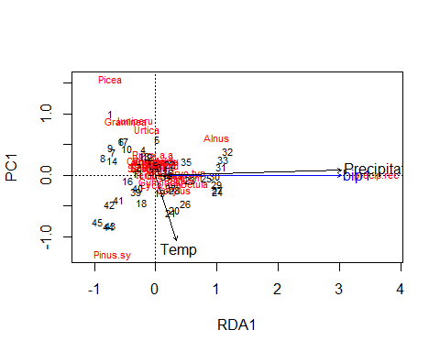

ordisurf(x=RDA_Data_tjul_annp,RDA_Data$temp.rec)

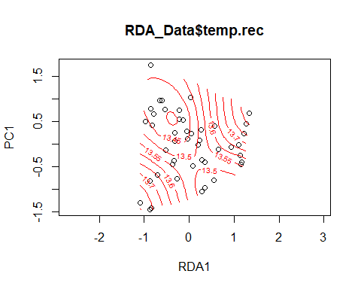

##   
## Family: gaussian   
## Link function: identity   
##   
## Formula:  
## y ~ s(x1, x2, k = 10, bs = "tp", fx = FALSE)  
##   
## Estimated degrees of freedom:  
## 2.31 total = 3.31   
##   
## REML score: 44.18058

ordisurf(x=RDA_Data_tjul_annp,RDA_Data$precip.rec)

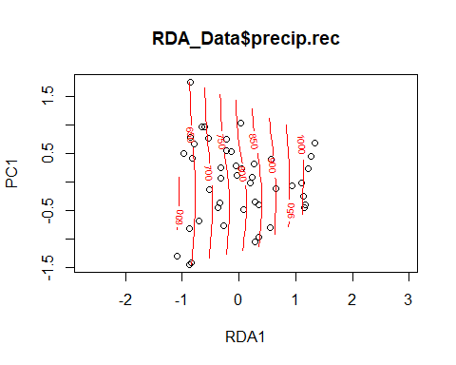

##   
## Family: gaussian   
## Link function: identity   
##   
## Formula:  
## y ~ s(x1, x2, k = 10, bs = "tp", fx = FALSE)  
##   
## Estimated degrees of freedom:  
## 7.5 total = 8.5   
##   
## REML score: 172.8644

Precipitation appears to be a stronger determinant of variance than Temperature. However, there is no clear trend here.